**DAILY ONLINE ACTIVITIES SUMMARY**

|  |  |  |  |  |  |  |  |  |
| --- | --- | --- | --- | --- | --- | --- | --- | --- |
| **Date:** | **14/06/2020** | | | | | **Name:** | **Manish B Shriyan** | |
| **Sem & Sec** | **8th sem B sec** | | | | | **USN:** | **4AL16CS131** | |
| **Online Test Summary** | | | | | | | | |
| **Subject** | | **--** | | | | | | |
| **Max. Marks** | | **--** | | **Score** | | | **--** | |
| **Certification Course Summary** | | | | | | | | |
| **Course** | **Introduction to Amazon Elastic Compute Cloud Chapter 2 (EC2)** | | | | | | | |
| **Certificate Provider** | | | **AWS** | | **Duration** | | | **2.1 Hours** |
| **Coding Challenges** | | | | | | | | |
| **Problem Statement:**  **Write C program to first non-repeating character** | | | | | | | | |
| **Status: Solved** | | | | | | | | |
| **Uploaded the report in Github** | | | | | **Uploaded** | | | |
| **If yes Repository name** | | | | | **ManishShriyan** | | | |
| **Uploaded the report in slack** | | | | | **Yes** | | | |

Online Test Details:

--

Certification Course Details:

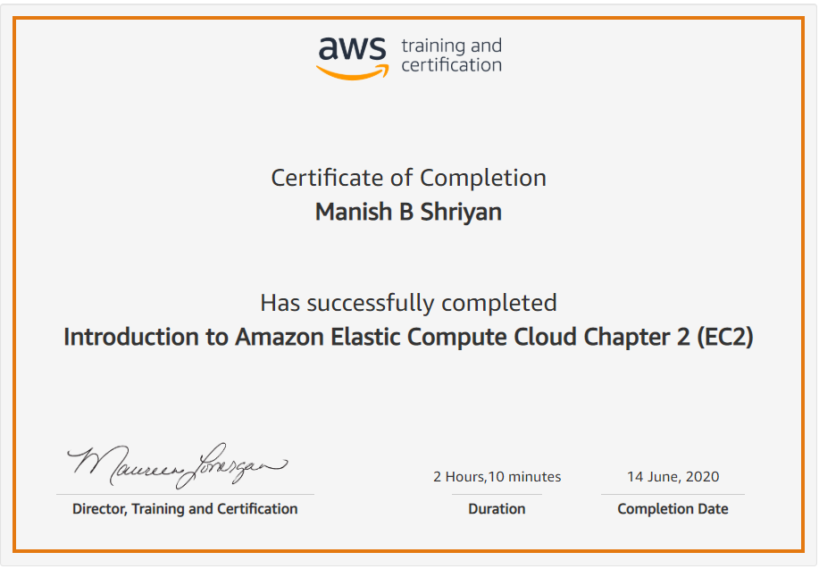

Coding Challenges Details:

|  |
| --- |
|  |
|  |  |
|  |  |
|  |  |
|  |  |
|  |  |
|  |  |
|  |  |
|  |  |
|  |  |
|  |  |

**#include<stdlib.h>**

**#include<stdio.h>**

**#define NO_OF_CHARS 256**

**int *get_char_count(char *str)**

**{**

**int *count = (int *)calloc(sizeof(int), NO_OF_CHARS);**

**int i;**

**for (i = 0; *(str+i); i++)**

**count[*(str+i)]++;**

**return count;**

**}**

**int first_non_repeating_character(char *str)**

**{**

**int *count = get_char_count(str);**

**int index = -1, i;**

**for (i = 0; *(str+i); i++)**

**{**

**if (count[*(str+i)] == 1)**

**{**

**index = i;**

**break;**

**}**

**}**

**free(count);**

**return index;**

**}**

**int main()**

**{**

**char str[NO_OF_CHARS];**

**printf("\nEnter the string : ");**

**scanf("%s",&str);**

**int index = first_non_repeating_character(str);**

**if (index == -1)**

**printf("All the characters are repetitive");**

**else**

**printf("First non-repeating character is %c", str[index]);**

**getchar();**

**return 0;**

**}**

**ts(list1, N)**